2.1 Vector-Valued Functions

- Find the domain of the following vector functions.
- .
has a domain of .
has a domain of .
has a domain of .
Therefore, has a domain of .

has a domain of .
has a domain of .
has a domain of .
Therefore, has a domain of .

has a domain of .
has a domain of .
has a domain of .
Therefore, has a domain of .

has a domain of .
has a domain of .
has a domain of .
Therefore, has a domain of .

For we need . Therefore, has a domain of .
has a domain of .
has a domain of .
Therefore, has a domain of .

- Find any three different parameterizations of the graph on the interval .

- If , then and so we have with .
- If , then and so we have with .
- If , then and so we have with .

- Find any three different parameterization of the graph of on the interval

- If , then and so we have with .
- If , then and so we have with .
- If , then and so we have with .

- Find any three different parameterization for a single tracing of the graph of .

This is a circle of radius 2.
- If , then and so we have with .
- If , then and so we have with .
- If , then and so we have with .

- Match the parametric equations with the graphs below. Give reasons for your choices.
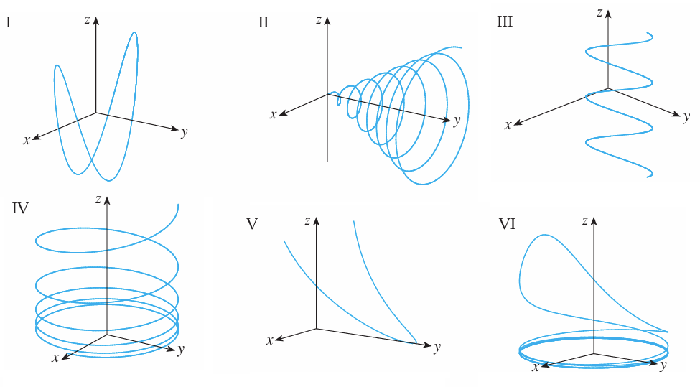

- for .

In the x and z direction we have a circular shape (because of the sine and cosine) with an increasing radius (which comes from the coefficient of the t). Note that the radii of the circles increases as the y-coordinate increases.

Therefore, this vector function goes with graph II.

In the x and y direction we have a circular shape (because of the sine and cosine) with a fixed radius of 1 (because of the coefficient of 1). The z-coordinate decreases (quickly and then more slowly) as t increases.

Therefore, this vector function goes with graph IV.

In the x and z direction we have a parabola shape. The y-coordinate decreases (quickly and then more slowly) as t increases.

Therefore, this vector function goes with graph V.

In the x and y direction we have a circular shape (because of the sine and cosine) with a fixed radius of 1 (because of the coefficient of 1). The z-coordinate also cycles between -1 and 1 but at a quicker rate than the x and y directions can form a circle. Specifically for every half circle sketched in the x and y directions the z coordinate fully oscillates between -1 and 1.

Therefore, this vector function goes with graph I.

- for .

In the x and y direction we have a circular shape (because of the sine and cosine) with a fixed radius of 1 (because of the coefficient of 1). The z-coordinate is always positive and increases (slowly at first and then more quickly).

Therefore, this vector function goes with graph VI.

In the x and y direction we have a values that oscillate between 0 and 1 (due to the sine and cosine being squared with leading coefficients of 1). The z-coordinate is always positive and increases at a linear rate.

Therefore, this vector function goes with graph III.

- True or False: The functions and generate the same curve.

False. By simply sketching these curves we can see that they are not the same.

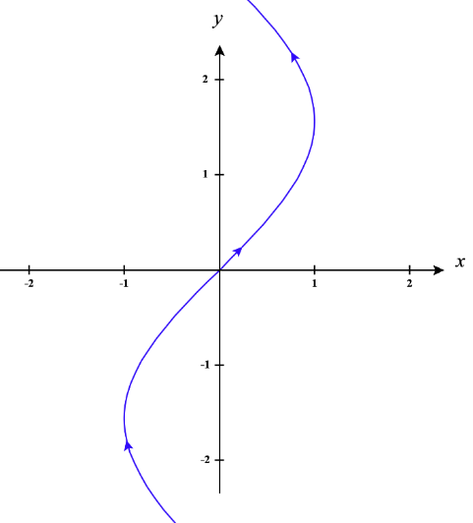
- Sketch the curve with the given vector equation. Indicate with an arrow the direction in which t increases.

Note that .

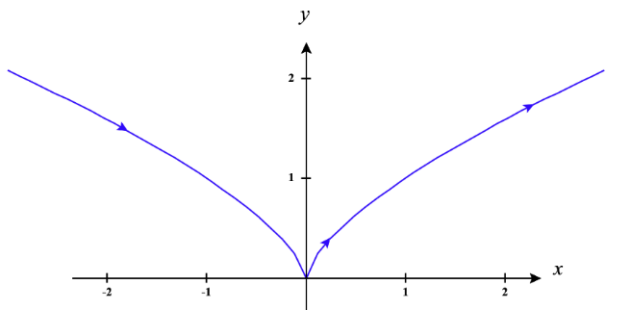

Note that .

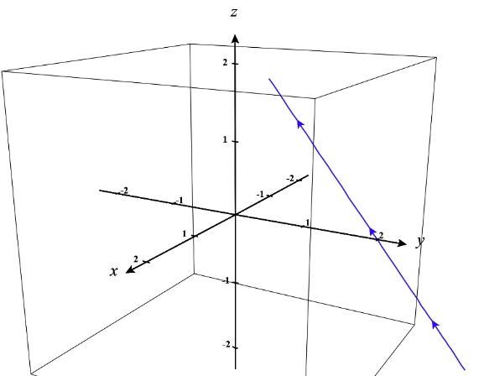
We can see right away this is the equation of a line from chapter 1.
When the function is at the point and when the function is at the point .

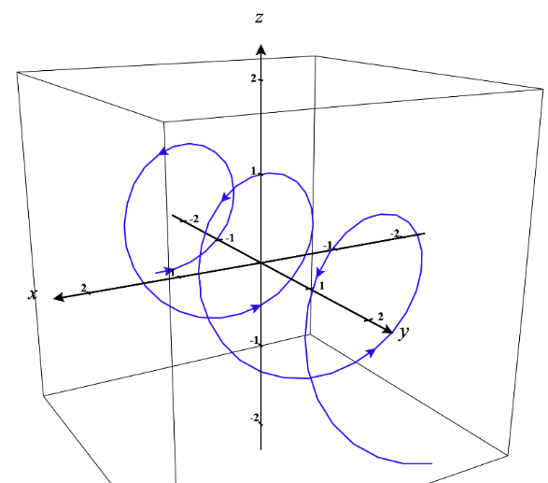
In the x and z directions we have circles of radius 1. The y-coordinate increases without bound as the circles are sketched.

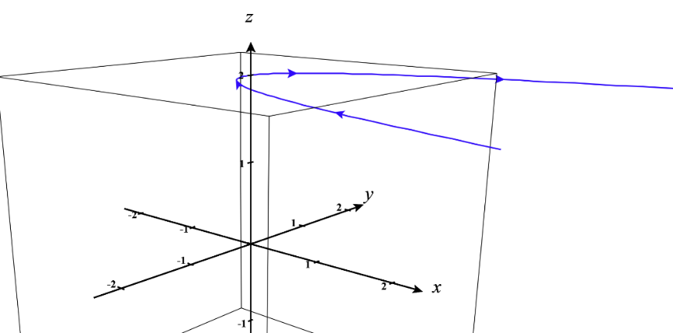
In the x and y directions we have a sideways parabola. The z-coordinate is fixed at 2.

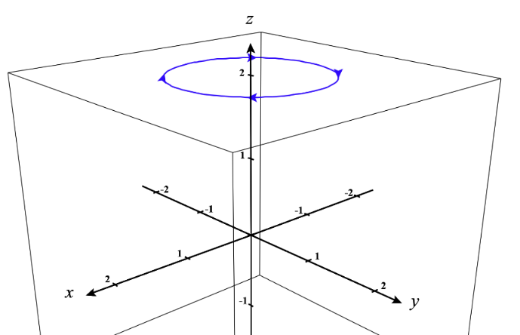
In the x and y directions we have circles of radius 1. The z-coordinate is fixed at 2.

